Publishing .NET Applications (Self-Contained vs Framework-Dependent)

1. Prerequisites
Before publishing, ensure:
- .NET SDK is installed
- dotnet --version
- Your project builds successfully
- dotnet build
- You are inside the project folder (where .csproj exists)
- cd ConsoleLearning
⚠️ dotnet publish must be run from the project directory, not the solution directory.

2. Key Concepts (Quick Understanding)

Framework-Dependent Deployment (FDD)
- Application depends on .NET runtime installed on target machine
- Smaller output size
- Faster publish
- Runtime must be installed separately

Self-Contained Deployment (SCD)
- Application includes .NET runtime inside output
- Larger output size
- Runs on machine without .NET installed
- OS-specific

3. Framework-Dependent Deployment (FDD)

3.1 When to Use FDD
Use FDD when: - Target machine already has .NET installed - Internal/company servers - Docker images with .NET base image - You want smaller binaries
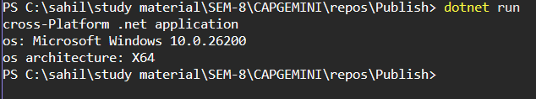

3.2 Command to Publish (Framework-Dependent)
dotnet publish -c Release
This publishes the application using default framework-dependent mode.
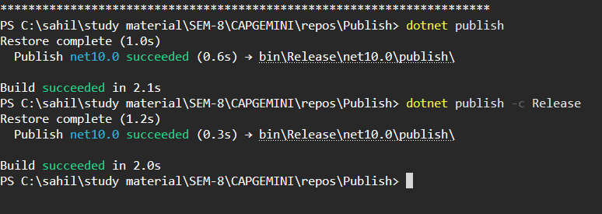

3.3 Output Location

After publishing, files are created at:
bin/
└── Release/
└── net8.0/
└── publish/

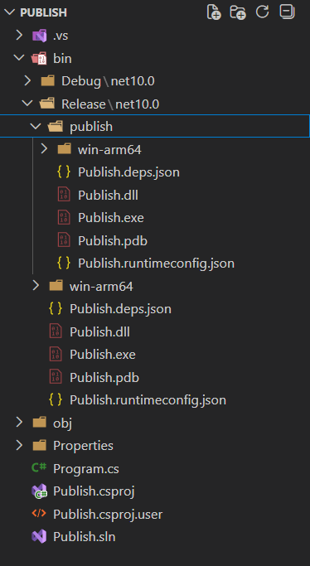

3.4 Files Generated (Important)
- .dll → Main application
- .deps.json
- .runtimeconfig.json
To run the app:
dotnet ConsoleLearning.dll
❗ Requires matching .NET runtime installed on the machine

3.5 Verify Framework Dependency
Check runtime config:
{
"framework": {
"name": "Microsoft.NETCore.App",
"version": "8.0.0"
}
}
This confirms framework-dependent mode.

4. Self-Contained Deployment (SCD)

4.1 When to Use SCD
Use SCD when: - Target machine has no .NET installed - Client systems - Desktop utilities - Exam / submission / offline delivery

4.3 Command to Publish (Self-Contained)
dotnet publish -c Release -r win-x64 --self-contained true

4.4 Output Location

bin/
└── Release/
└── net8.0/
└── win-x64/
└── publish/

4.5 Files Generated
- .exe (Windows)
- .NET runtime files
- No dependency on external runtime
Run directly:
ConsoleLearning.exe
✅ Works even if .NET is NOT installed

4.6 Verify Self-Contained Mode
Check runtime config file:
{
"includedFrameworks": [
{
"name": "Microsoft.NETCore.App",
"version": "8.0.0"
}
]
}
This confirms self-contained deployment.

5. Optional: Single-File Publishing

5.1 Framework-Dependent Single File
dotnet publish -c Release -p:PublishSingleFile=true

5.2 Self-Contained Single File
dotnet publish -c Release -r win-x64 --self-contained true -p:PublishSingleFile=true
Output: - One .exe file - Best for distribution

6. Common Mistakes & Fixes

Mistake 1: Running from solution folder
❌ dotnet publish fails
✅ Fix:
cd ConsoleLearning

Mistake 2: Expecting .exe in FDD
❌ Only .dll generated
✅ Fix: Use self-contained mode

7. Recommended Usage (Industry Practice)
Scenario | Recommended Mode
Internal servers | Framework-Dependent
Client machines | Self-Contained
Exam submission | Self-Contained
Docker | Framework-Dependent
Utilities | Self-Contained Single File

8. Final Checklist
✔ Build succeeds ✔ Correct project folder ✔ Correct RID ✔ Correct deployment mode ✔ Verified output

